Supplementary Table 1: IL-6 ELISA Kit Information and Assay Performance Parameters

Indicator | Method | Manufacturer | Catalog No. | Specification | Detection range | Sensitivity | Intra-assay CV | Inter-assay CV | Remarks
IL-6 | Sandwich ELISA | Yeasen (Shanghai) | 97068ES (97068ES48/97068ES96) | 48T/96T | 7.81–500 pg/mL | 2.53 pg/mL | 6.1% | 7.6% | Dilution linearity: 75–116%; recovery: 75–108%

Supplementary Table 2: TNF-α ELISA Kit Information, Assay Conditions, and Precision Parameters

Indicator | Method | Manufacturer (country/region of origin) | Catalog No. | Specification | Sample type | Standard range / highest standard concentration | Readout wavelength | Precision (CV) | Storage conditions
TNF-α | Double-antibody sandwich ELISA. | Bioswamp (Wuhan Beinlai Biotechnology Co., Ltd., Wuhan, China). | HM10001 | 48T/96T | Serum | Highest standard: 1280 pg/mL (a standard curve was generated using serial dilutions according to the manufacturer’s instructions). | 450 nm | Intra-assay variation <10%; inter-assay variation <10% (per the manufacturer’s instructions). | Store at 2–8 °C, protected from light.

Supplementary Table 3. Normality tests for key continuous outcomes

Indicator | group | Shapiro–Wilk W | p value
age (years) | A (n=32) | 0.982 | 0.863
age (years) | B (n=28) | 0.972 | 0.647
BMI (kg/m²) | A (n=32) | 0.963 | 0.321
BMI (kg/m²) | B (n=28) | 0.970 | 0.577
time from admission to surgery/endoscopic intervention (h) | A (n=32) | 0.974 | 0.626
time from admission to surgery/endoscopic intervention (h) | B (n=28) | 0.973 | 0.666
time from symptom onset to admission (d) | A (n=32) | 0.942 | 0.085
time from symptom onset to admission (d) | B (n=28) | 0.958 | 0.319
body temperature (°C) | A (n=32) | 0.960 | 0.273
body temperature (°C) | B (n=28) | 0.954 | 0.243
heart rate (beat/min) | A (n=32) | 0.929 | 0.036
heart rate (beat/min) | B (n=28) | 0.928 | 0.055
operative time (min) | A (n=32) | 0.989 | 0.983
operative time (min) | B (n=28) | 0.948 | 0.181
intraoperative blood loss (mL) | A (n=32) | 0.962 | 0.314
intraoperative blood loss (mL) | B (n=28) | 0.969 | 0.558
time to first ambulation (d) | A (n=32) | 0.979 | 0.755
time to first ambulation (d) | B (n=28) | 0.979 | 0.828
hospital stay (d) | A (n=32) | 0.967 | 0.429
hospital stay (d) | B (n=28) | 0.911 | 0.021
average hospitalization expenses (yuan) | A (n=32) | 0.962 | 0.311
average hospitalization expenses (yuan) | B (n=28) | 0.973 | 0.666
IL-6 (pg/mL) (1 hour before surgery) | A (n=32) | 0.984 | 0.899
IL-6 (pg/mL) (1 hour before surgery) | B (n=28) | 0.977 | 0.773
IL-6 (pg/mL) (48 hours after surgery) | A (n=32) | 0.952 | 0.165
IL-6 (pg/mL) (48 hours after surgery) | B (n=28) | 0.975 | 0.723
TNF-α (pg/mL) (1 hour before surgery) | A (n=32) | 0.978 | 0.741
TNF-α (pg/mL) (1 hour before surgery) | B (n=28) | 0.924 | 0.045
TNF-α (pg/mL) (48 hours after surgery) | A (n=32) | 0.967 | 0.431
TNF-α (pg/mL) (48 hours after surgery) | B (n=28) | 0.973 | 0.654
CRP (mg/L) (1 hour before surgery) | A (n=32) | 0.980 | 0.812
CRP (mg/L) (1 hour before surgery) | B (n=28) | 0.947 | 0.166
CRP (mg/L) (48 hours after surgery) | A (n=32) | 0.969 | 0.469
CRP (mg/L) (48 hours after surgery) | B (n=28) | 0.966 | 0.469
PCT (ng/mL) (1 hour before surgery) | A (n=32) | 0.947 | 0.116
PCT (ng/mL) (1 hour before surgery) | B (n=28) | 0.958 | 0.320
PCT (ng/mL) (48 hours after surgery) | A (n=32) | 0.962 | 0.306
PCT (ng/mL) (48 hours after surgery) | B (n=28) | 0.923 | 0.042
DA (µg/L) (1 hour before surgery) | A (n=32) | 0.959 | 0.255
DA (µg/L) (1 hour before surgery) | B (n=28) | 0.907 | 0.017
DA (µg/L) (48 hours after surgery) | A (n=32) | 0.936 | 0.058
DA (µg/L) (48 hours after surgery) | B (n=28) | 0.953 | 0.233
SP (µg/L) (1 hour before surgery) | A (n=32) | 0.909 | 0.011
SP (µg/L) (1 hour before surgery) | B (n=28) | 0.934 | 0.077
SP (µg/L) (48 hours after surgery) | A (n=32) | 0.932 | 0.043
SP (µg/L) (48 hours after surgery) | B (n=28) | 0.899 | 0.011
5-HT (µg/L) (1 hour before surgery) | A (n=32) | 0.969 | 0.480
5-HT (µg/L) (1 hour before surgery) | B (n=28) | 0.945 | 0.147
5-HT (µg/L) (48 hours after surgery) | A (n=32) | 0.961 | 0.290
5-HT (µg/L) (48 hours after surgery) | B (n=28) | 0.873 | 0.003
PGE2 (µg/L) (1 hour before surgery) | A (n=32) | 0.938 | 0.068
PGE2 (µg/L) (1 hour before surgery) | B (n=28) | 0.959 | 0.324
PGE2 (µg/L) (48 hours after surgery) | A (n=32) | 0.973 | 0.587
PGE2 (µg/L) (48 hours after surgery) | B (n=28) | 0.968 | 0.536
(Group A = ERAT Group; Group B = laparoscopic appendectomy Group. The Shapiro–Wilk test was used as the primary basis for assessment (more commonly applied/more sensitive for small samples). Decision threshold: p < 0.05 was considered evidence of deviation from normality.）
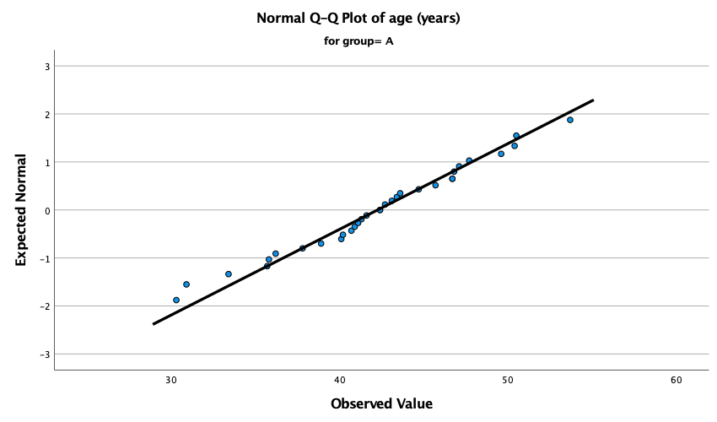
Supplementary Fig. 1 (Normal Q–Q plot of age (years) in group A).
(Note: This figure shows the normal Q–Q plot for age in group A, comparing the observed age values with the theoretical quantiles of a normal distribution. Most data points lie close to the reference line, indicating that age in group A is approximately normally distributed, with no obvious substantial deviation from normality.)
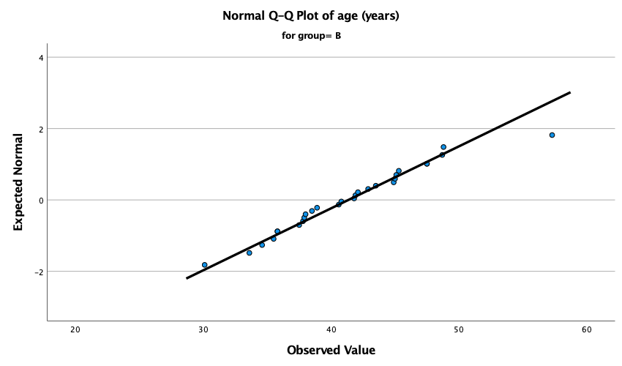
Supplementary Fig. 2 (Normal Q–Q plot of age (years) in group B.)
(Note: This figure shows the normal Q–Q plot for age in group B, comparing the observed age values with the theoretical quantiles of a normal distribution. Most data points are distributed close to the reference line, suggesting that age in group B is approximately normally distributed,
although a slight deviation is visible at the upper end.)
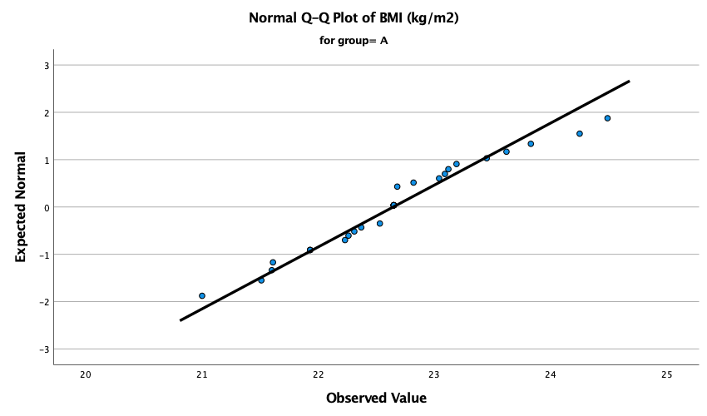
Supplementary Fig. 3 (Normal Q–Q plot of BMI (kg/m²) in group A.)
(Note: This figure shows the normal Q–Q plot for BMI in group A, comparing the observed BMI values with the theoretical quantiles of a normal distribution. Most data points lie close to the reference line, suggesting that BMI in group A is approximately normally distributed, with only slight deviation at the upper end.)

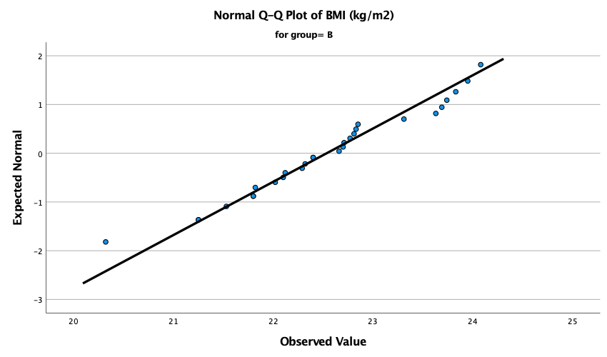
Supplementary Fig. 4 (Normal Q–Q plot of BMI (kg/m²) in group B.)
(Note: This figure shows the normal Q–Q plot for BMI in group B, comparing the observed BMI values with the theoretical quantiles of a normal distribution. Most data points are distributed close to the reference line, indicating that BMI in group B is approximately normally distributed, with minor deviation at the tails.)

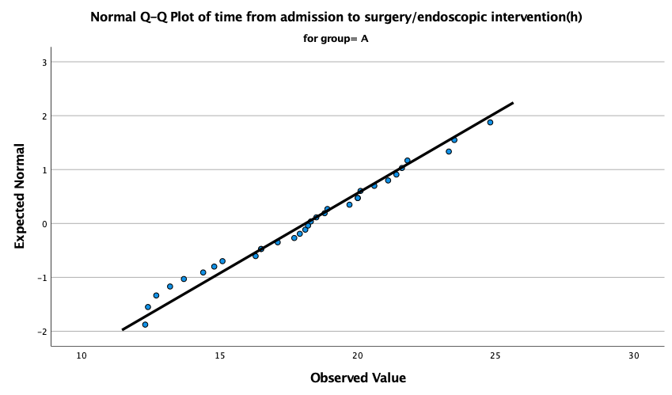
Supplementary Fig. 5 (Normal Q–Q plot of time from admission to surgery/endoscopic intervention (h) in group A.)
(Note: This figure shows the normal Q–Q plot for the time from admission to surgery/endoscopic intervention in group A. The observed values
are generally aligned with the reference line, indicating that this variable in group A is approximately normally distributed.)

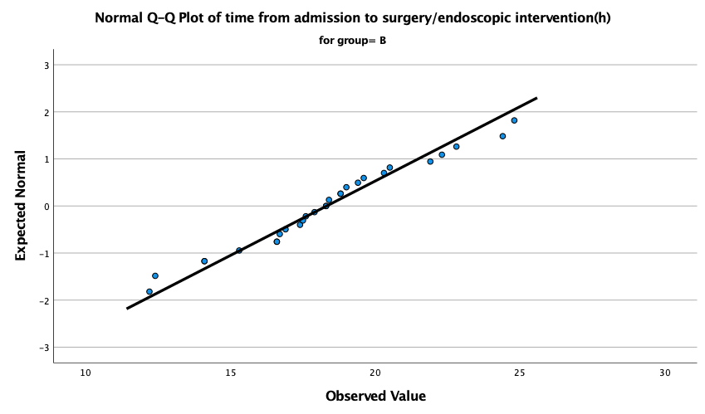
Supplementary Fig. 6 (Normal Q–Q plot of time from admission to surgery/endoscopic intervention (h) in group B.)
(Note: This figure shows the normal Q–Q plot for the time from admission to surgery/endoscopic intervention in group B. Most data points lie
close to the reference line, suggesting an approximately normal distribution, although slight deviation is present at the upper end.)

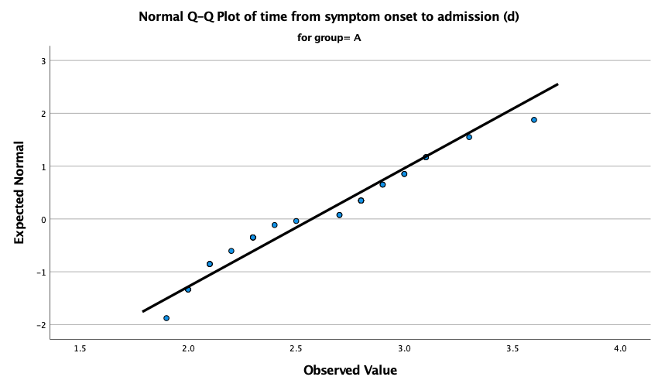
Supplementary Fig. 7 (Normal Q–Q plot of time from symptom onset to admission (d) in group A.)
(Note: This figure shows the normal Q–Q plot for the time from symptom onset to admission in group A. The observed values are generally close
to the reference line, indicating that this variable in group A is approximately normally distributed.)

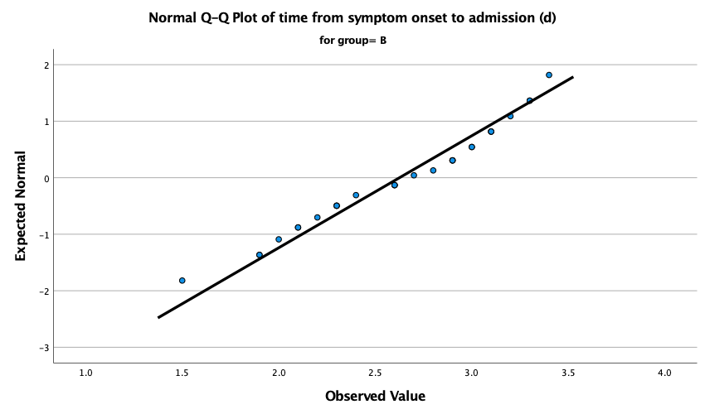
Supplementary Fig. 8 (Normal Q–Q plot of time from symptom onset to admission (d) in group B.)
(Note: This figure shows the normal Q–Q plot for the time from symptom onset to admission in group B. Most data points are distributed near the
reference line, suggesting that this variable in group B is approximately normally distributed, with only slight deviation at the ends.)
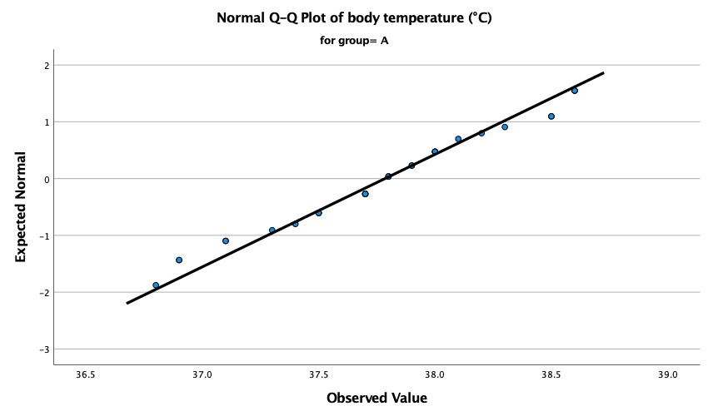
Supplementary Fig. 9 (Normal Q–Q plot of body temperature (°C) in group A.)
(Note: This figure shows the normal Q–Q plot for body temperature in group A. The observed values are generally aligned with the reference
line, indicating that body temperature in group A is approximately normally distributed.)

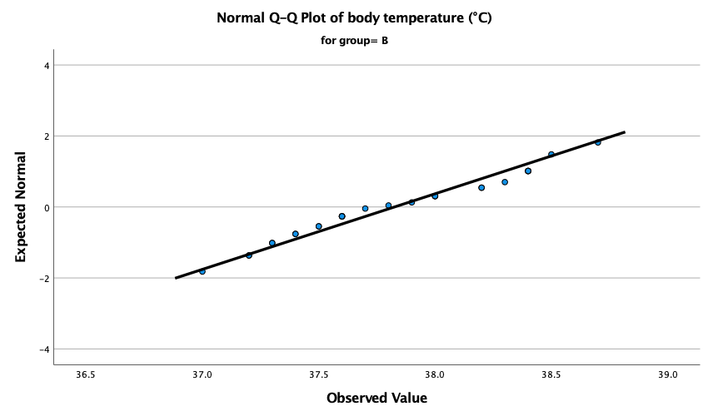
Supplementary Fig. 10 (Normal Q–Q plot of body temperature (°C) in group B.)
(Note: This figure shows the normal Q–Q plot for body temperature in group B. Most data points lie close to the reference line, suggesting that
body temperature in group B is approximately normally distributed, with no obvious substantial deviation from normality.)

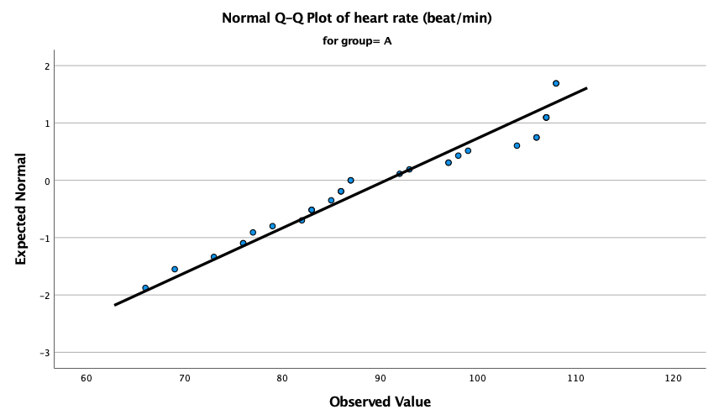
Supplementary Fig. 11 (Normal Q–Q plot of heart rate (beat/min) in group A.)
(Note: This figure shows the normal Q–Q plot for heart rate in group A, comparing the observed values with the theoretical quantiles of a normal
distribution. A slight deviation from the reference line is visible, suggesting a mild departure from normality.)

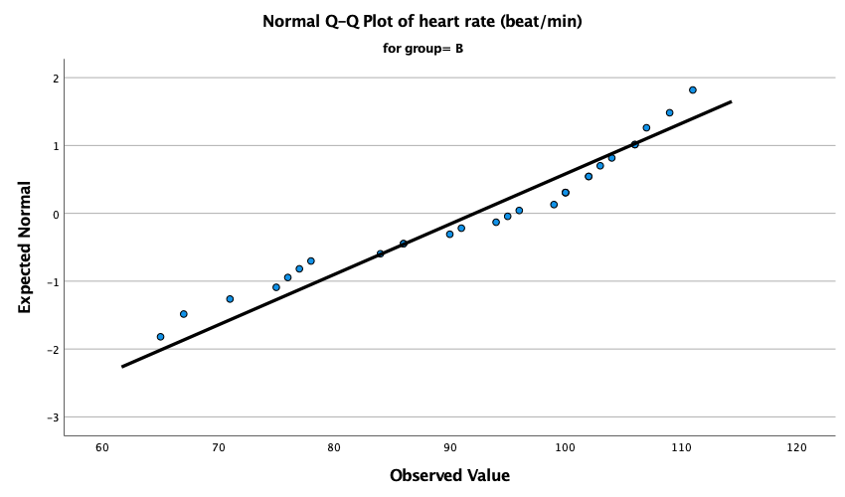
Supplementary Fig. 12 (Normal Q–Q plot of heart rate (beat/min) in group B.)
(Note: This figure shows the normal Q–Q plot for heart rate in group B, comparing the observed values with the theoretical quantiles of a normal distribution. Most data points lie close to the reference line, suggesting an approximately normal distribution, although slight tail deviation may
be present.)

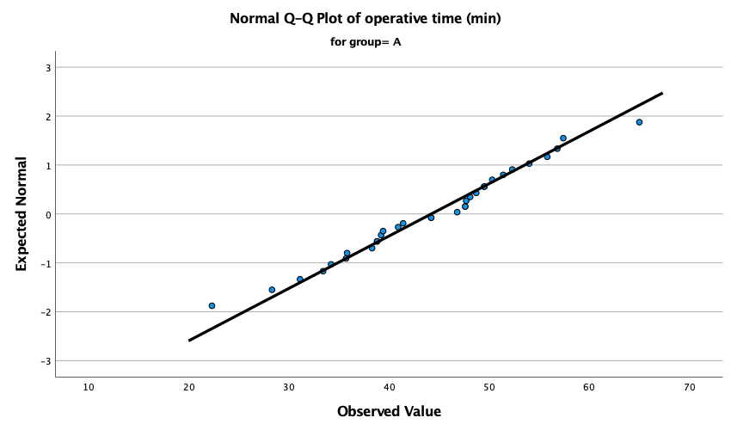
Supplementary Fig. 13 (Normal Q–Q plot of operative time (min) in group A.)
(Note: This figure shows the normal Q–Q plot for operative time in group A, comparing the observed values with the theoretical quantiles of a
normal distribution. Most data points lie close to the reference line, indicating that operative time in group A is approximately normally distributed.)

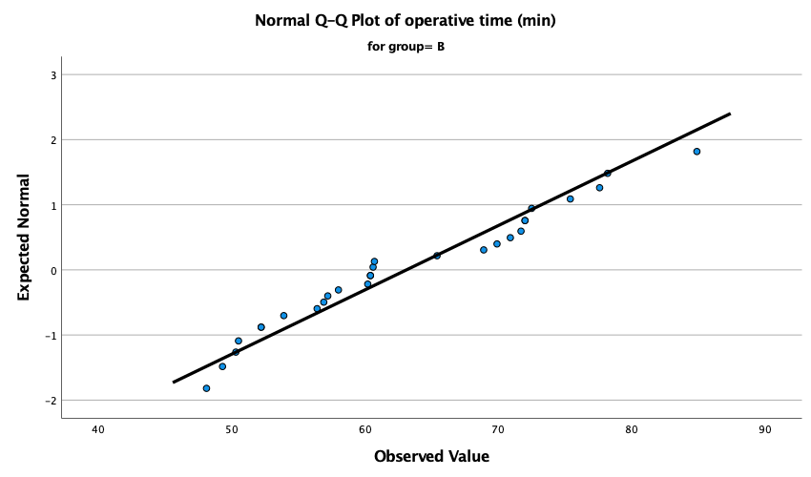
Supplementary Fig. 14 (Normal Q–Q plot of operative time (min) in group B.)
(Note: This figure shows the normal Q–Q plot for operative time in group B, comparing the observed values with the theoretical quantiles of a
normal distribution. Most data points lie close to the reference line, indicating that operative time in group B is approximately normally distributed.)

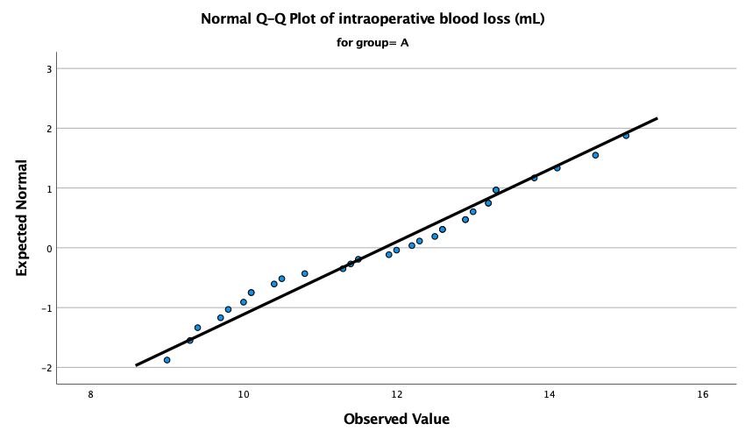
Supplementary Fig. 15 (Normal Q–Q plot of intraoperative blood loss (mL) in group A.)
(Note: This figure shows the normal Q–Q plot for intraoperative blood loss in group A, comparing the observed values with the theoretical
quantiles of a normal distribution. Most data points lie close to the reference line, suggesting an approximately normal distribution.)

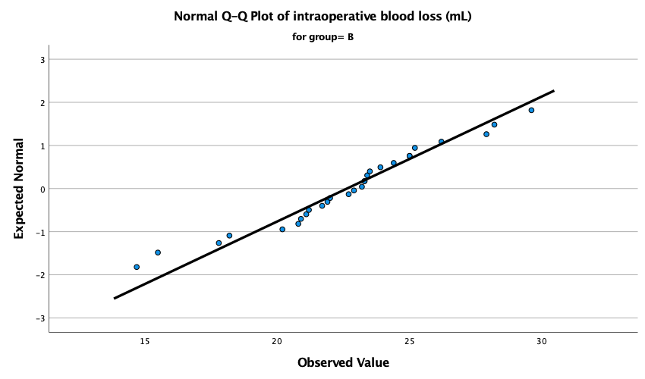
Supplementary Fig. 16 (Normal Q–Q plot of intraoperative blood loss (mL) in group B.)
(Note: This figure shows the normal Q–Q plot for intraoperative blood loss in group B, comparing the observed values with the theoretical
quantiles of a normal distribution. Most data points lie close to the reference line, suggesting an approximately normal distribution.)

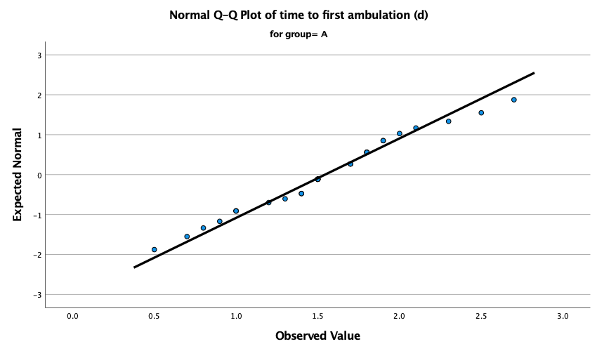
Supplementary Fig. 17 (Normal Q–Q plot of time to first ambulation (d) in group A.)
(Note: This figure shows the normal Q–Q plot for time to first ambulation in group A, comparing the observed values with the theoretical quantiles of a normal distribution. Most data points lie close to the reference line, indicating that this variable in group A is approximately
normally distributed.)

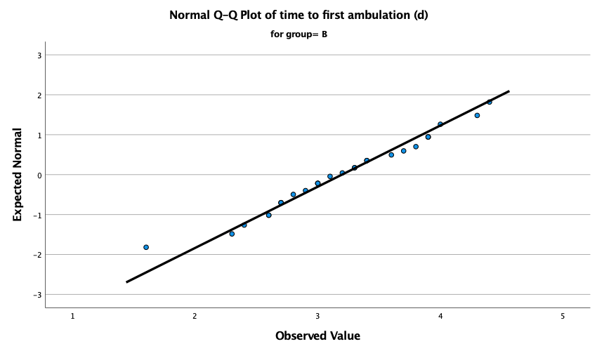
Supplementary Fig. 18 (Normal Q–Q plot of time to first ambulation (d) in group B.)
(Note: This figure shows the normal Q–Q plot for time to first ambulation in group B, comparing the observed values with the theoretical quantiles of a normal distribution. Most data points lie close to the reference line, indicating that this variable in group B is approximately
normally distributed.)
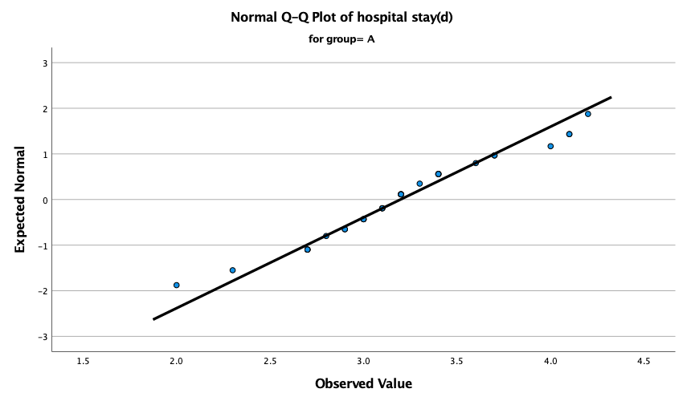
Supplementary Fig. 19 (Normal Q–Q plot of hospital stay (d) in group A.)
(Note: This figure shows the normal Q–Q plot for hospital stay in group A, comparing the observed values with the theoretical quantiles of a
normal distribution. Most data points lie close to the reference line, suggesting that hospital stay in group A is approximately normally distributed.)

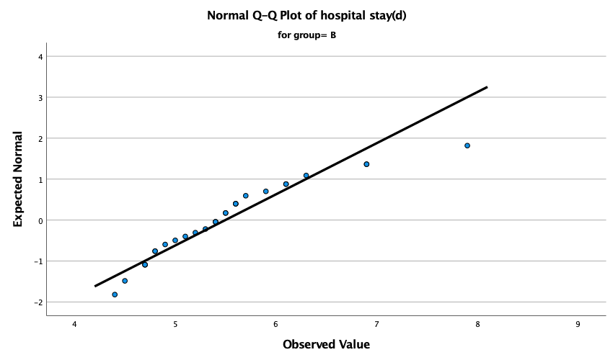
Supplementary Fig. 20 (Normal Q–Q plot of hospital stay (d) in group B.)
(Note: This figure shows the normal Q–Q plot for hospital stay in group B, comparing the observed values with the theoretical quantiles of a normal distribution. The Q–Q plot shows an overall approximately linear pattern across the central quantile range; however, a visible deviation
is present in the upper tail, suggesting a departure from normality.)
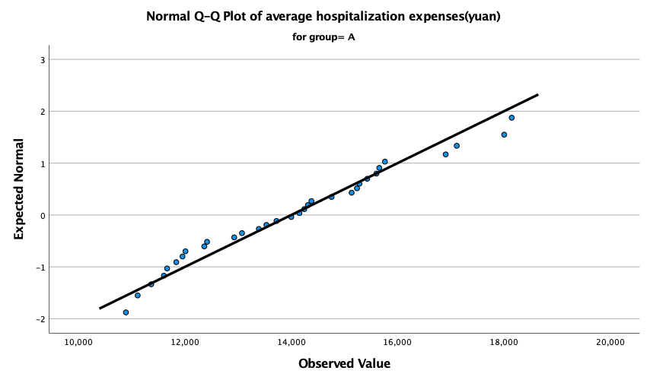
Supplementary Fig. 21 (Normal Q–Q plot of average hospitalization expenses (yuan) in group A.)
(Note: This figure shows the normal Q–Q plot for average hospitalization expenses in group A, comparing the observed values with the theoretical quantiles of a normal distribution. Most data points lie close to the reference line, suggesting an approximately normal distribution.)

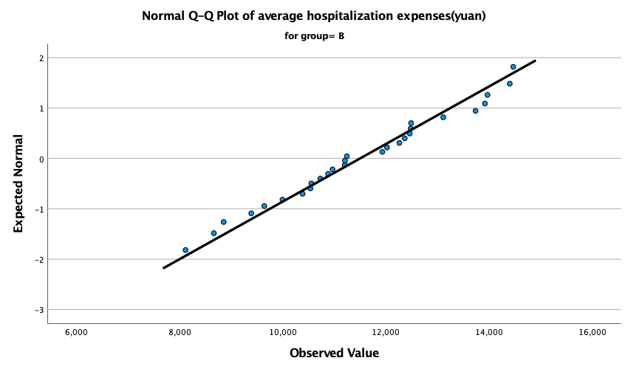
Supplementary Fig. 22 (Normal Q–Q plot of average hospitalization expenses (yuan) in group B.)
(Note: This figure shows the normal Q–Q plot for average hospitalization expenses in group B, comparing the observed values with the theoretical quantiles of a normal distribution. Most data points lie close to the reference line, suggesting an approximately normal distribution.)

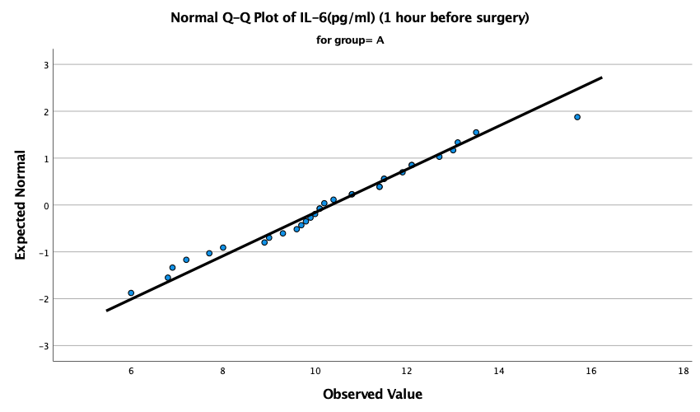
Supplementary Fig. 23 (Normal Q–Q plot of IL-6 (pg/mL) (1 hour before surgery) in group A.)
(Note: This figure shows the normal Q–Q plot for IL-6 measured 1 hour before surgery in group A, comparing the observed values with the theoretical quantiles of a normal distribution. Most data points lie close to the reference line, indicating an approximately normal distribution.)

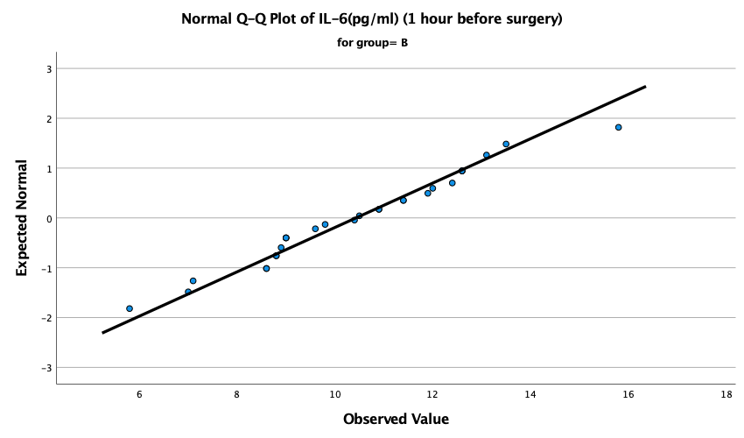
Supplementary Fig. 24 (Normal Q–Q plot of IL-6 (pg/mL) (1 hour before surgery) in group B.)
(Note: This figure shows the normal Q–Q plot for IL-6 measured 1 hour before surgery in group B, comparing the observed values with the theoretical quantiles of a normal distribution. Most data points lie close to the reference line, indicating an approximately normal distribution.)

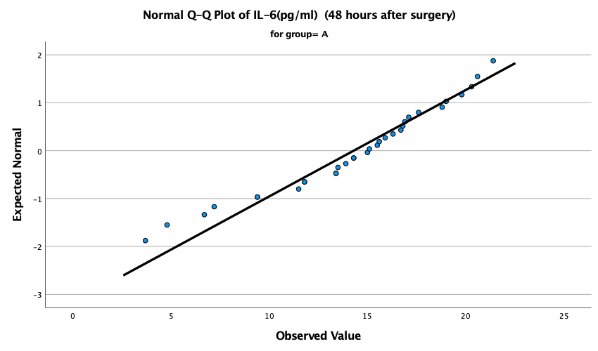
Supplementary Fig. 25 (Normal Q–Q plot of IL-6 (pg/mL) (48 hours after surgery) in group A.)
(Note: This figure shows the normal Q–Q plot for IL-6 measured 48 hours after surgery in group A, comparing the observed values with the theoretical quantiles of a normal distribution. Most data points lie close to the reference line, suggesting an approximately normal distribution.)

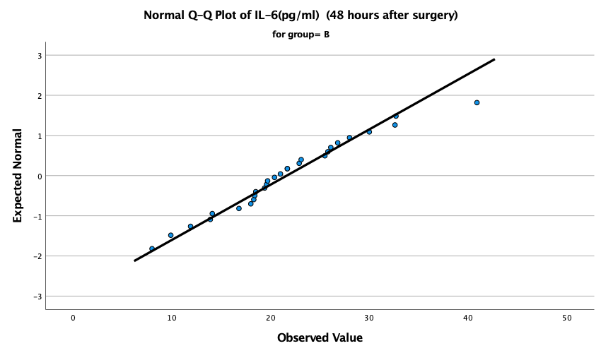
Supplementary Fig. 26 (Normal Q–Q plot of IL-6 (pg/mL) (48 hours after surgery) in group B.)
(Note: This figure shows the normal Q–Q plot for IL-6 measured 48 hours after surgery in group B, comparing the observed values with the theoretical quantiles of a normal distribution. Most data points lie close to the reference line, suggesting an approximately normal distribution.)

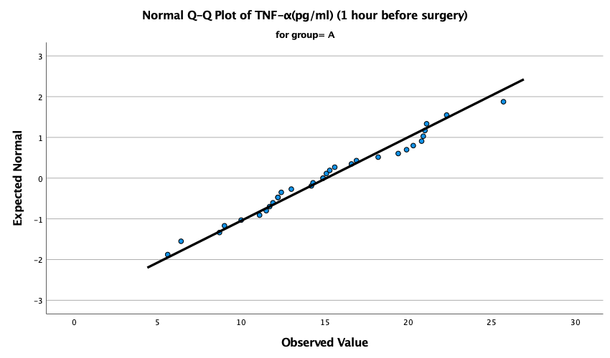
Supplementary Fig. 27 (Normal Q–Q plot of TNF-α (pg/mL) (1 hour before surgery) in group A.)
(Note: This figure shows the normal Q–Q plot for TNF-α measured 1 hour before surgery in group A, comparing the observed values with the theoretical quantiles of a normal distribution. Most data points lie close to the reference line, suggesting an approximately normal distribution.)

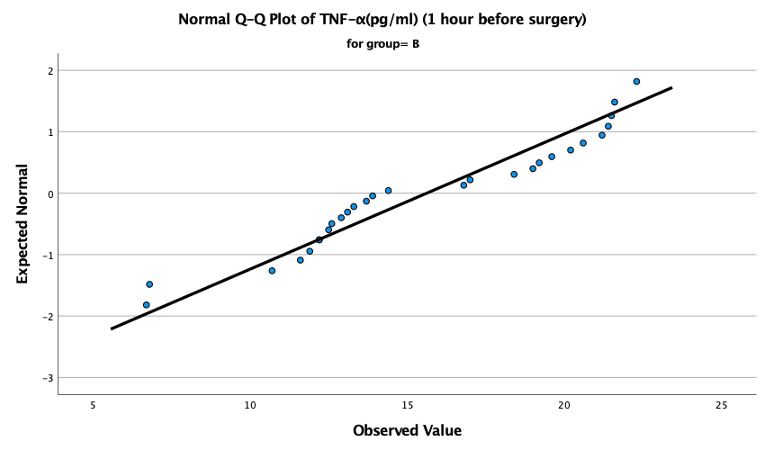
Supplementary Fig. 28 (Normal Q–Q plot of TNF-α (pg/mL) (1 hour before surgery) in group B.)
(Note: This figure shows the normal Q–Q plot for TNF-α measured 1 hour before surgery in group B, comparing the observed values with the theoretical quantiles of a normal distribution. A slight deviation from the reference line is present, suggesting a mild departure from normality.)

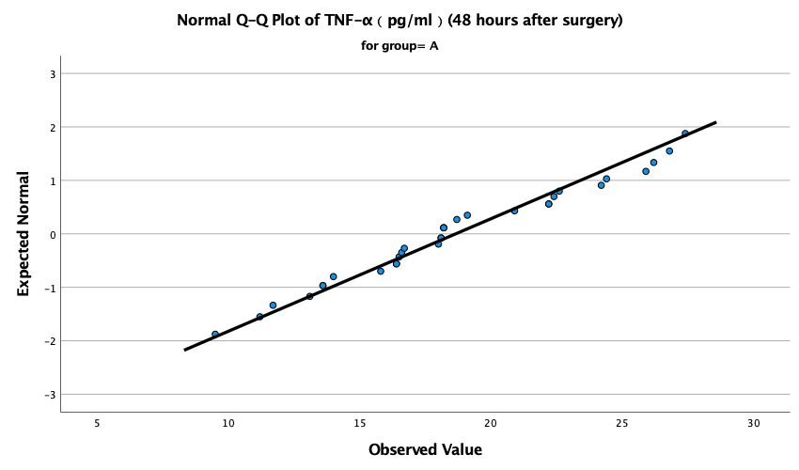
Supplementary Fig. 29 (Normal Q–Q plot of TNF-α (pg/mL) (48 hours after surgery) in group A.)
(Note: This figure shows the normal Q–Q plot for TNF-α measured 48 hours after surgery in group A, comparing the observed values with the theoretical quantiles of a normal distribution. Most data points lie close to the reference line, suggesting an approximately normal distribution.)

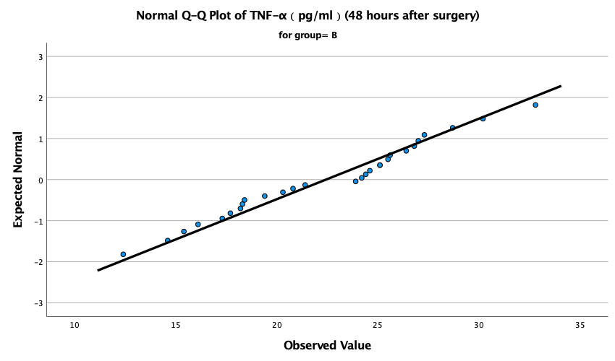
Supplementary Fig. 30 (Normal Q–Q plot of TNF-α (pg/mL) (48 hours after surgery) in group B.)
(Note: This figure shows the normal Q–Q plot for TNF-α measured 48 hours after surgery in group B, comparing the observed values with the theoretical quantiles of a normal distribution. Most data points lie close to the reference line, suggesting an approximately normal distribution.)

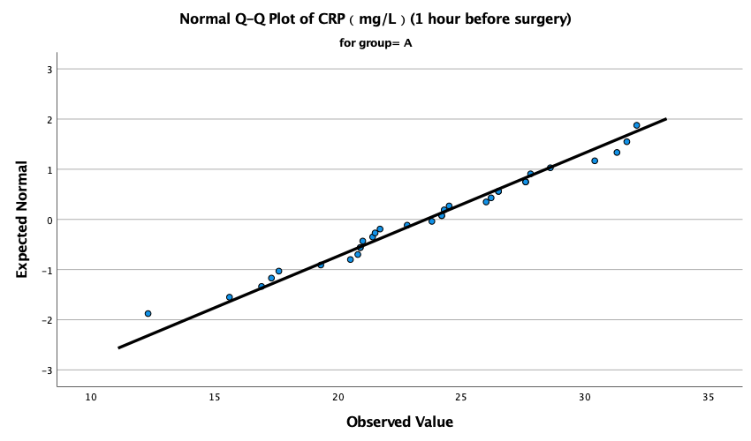
Supplementary Fig. 31 (Normal Q–Q plot of CRP (mg/L) (1 hour before surgery) in group A.)
(Note: This figure shows the normal Q–Q plot for CRP measured 1 hour before surgery in group A, comparing the observed values with the theoretical quantiles of a normal distribution. Most data points lie close to the reference line, indicating an approximately normal distribution.)

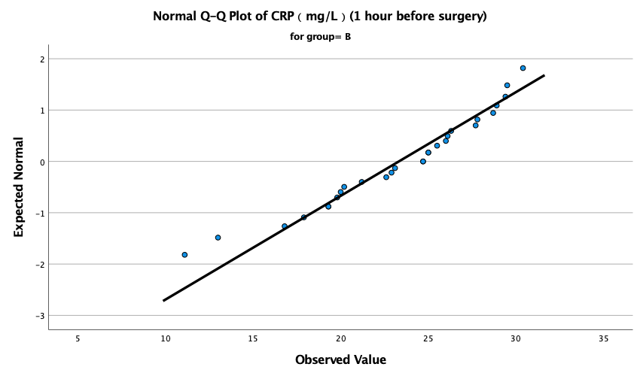
Supplementary Fig. 32 (Normal Q–Q plot of CRP (mg/L) (1 hour before surgery) in group B.)
(Note: This figure shows the normal Q–Q plot for CRP measured 1 hour before surgery in group B, comparing the observed values with the theoretical quantiles of a normal distribution. Most data points lie close to the reference line, indicating an approximately normal distribution.)

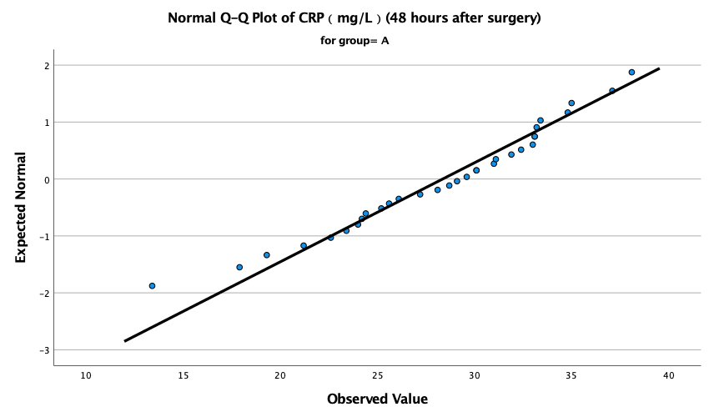
Supplementary Fig. 33 (Normal Q–Q plot of CRP (mg/L) (48 hours after surgery) in group A.)
(Note: This figure shows the normal Q–Q plot for CRP measured 48 hours after surgery in group A, comparing the observed values with the theoretical quantiles of a normal distribution. Most data points lie close to the reference line, suggesting an approximately normal distribution.)

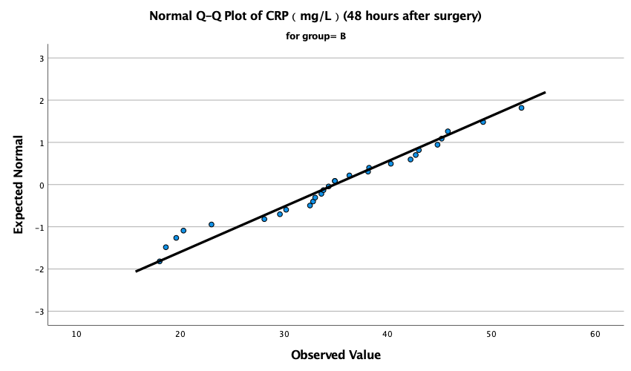
Supplementary Fig. 34 (Normal Q–Q plot of CRP (mg/L) (48 hours after surgery) in group B.)
(Note: This figure shows the normal Q–Q plot for CRP measured 48 hours after surgery in group B, comparing the observed values with the theoretical quantiles of a normal distribution. Most data points lie close to the reference line, suggesting an approximately normal distribution.)

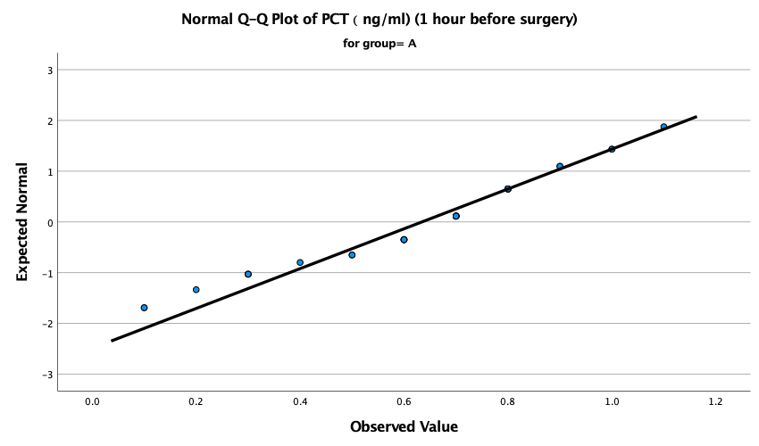
Supplementary Fig. 35 (Normal Q–Q plot of PCT (ng/mL) (1 hour before surgery) in group A.)
(Note: This figure shows the normal Q–Q plot for PCT measured 1 hour before surgery in group A, comparing the observed values with the theoretical quantiles of a normal distribution. Most data points lie close to the reference line, suggesting an approximately normal distribution.)

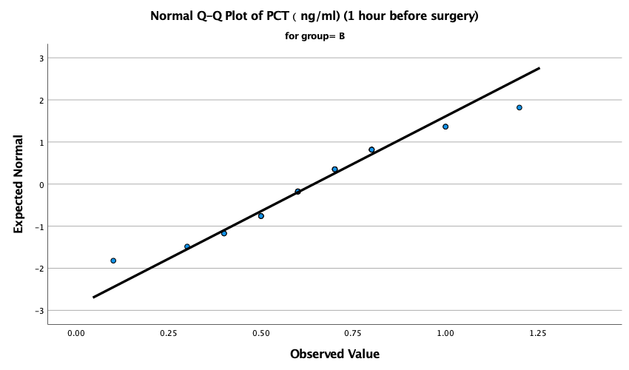
Supplementary Fig. 36 (Normal Q–Q plot of PCT (ng/mL) (1 hour before surgery) in group B.)
(Note: This figure shows the normal Q–Q plot for PCT measured 1 hour before surgery in group B, comparing the observed values with the theoretical quantiles of a normal distribution. Most data points lie close to the reference line, suggesting an approximately normal distribution.)

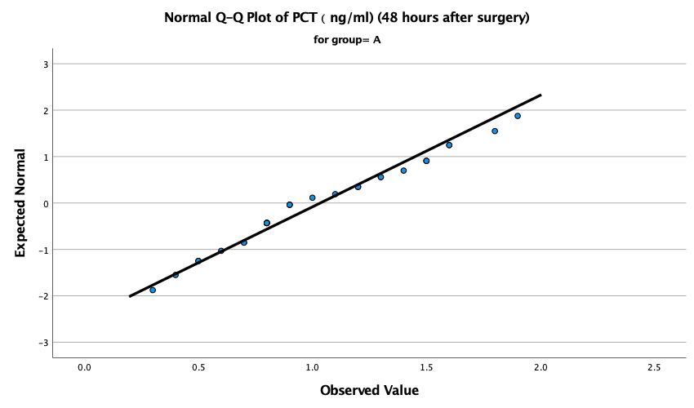
Supplementary Fig. 37 (Normal Q–Q plot of PCT (ng/mL) (48 hours after surgery) in group A.)
(Note: This figure shows the normal Q–Q plot for PCT measured 48 hours after surgery in group A, comparing the observed values with the theoretical quantiles of a normal distribution. Most data points lie close to the reference line, suggesting an approximately normal distribution.)

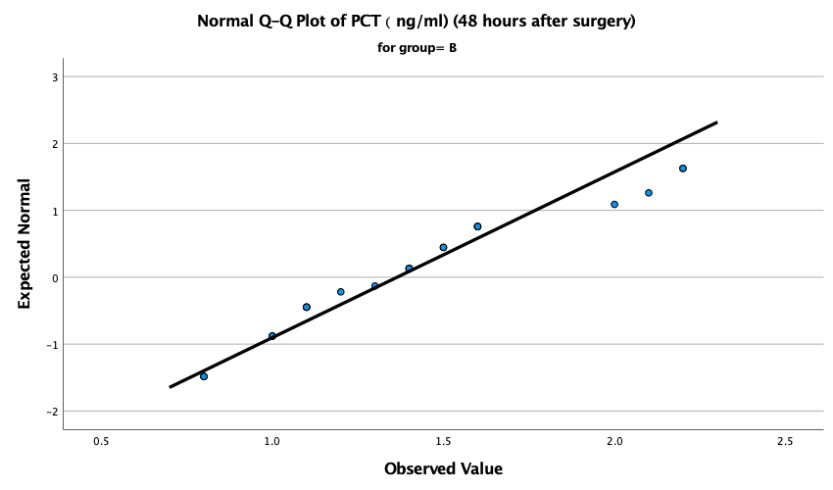
Supplementary Fig. 38 (Normal Q–Q plot of PCT (ng/mL) (48 hours after surgery) in group B.)
(Note: This figure shows the normal Q–Q plot for PCT measured 48 hours after surgery in group B, comparing the observed values with the theoretical quantiles of a normal distribution. A slight deviation from the reference line is visible, suggesting a mild departure from normality.)

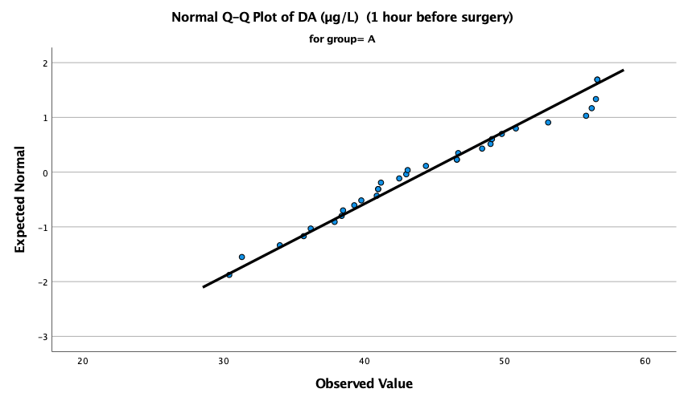
Supplementary Fig. 39 (Normal Q–Q plot of DA (µg/L) (1 hour before surgery) in group A.)
(Note: This figure shows the normal Q–Q plot for DA measured 1 hour before surgery in group A, comparing the observed values with the theoretical quantiles of a normal distribution. Most data points lie close to the reference line, suggesting an approximately normal distribution.)

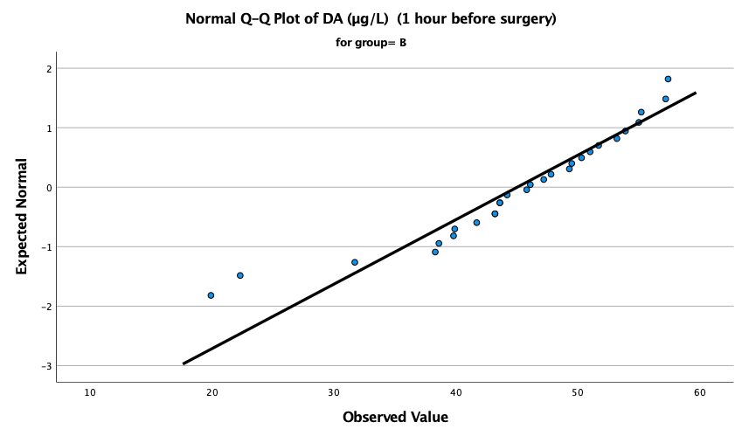
Supplementary Fig. 40 (Normal Q–Q plot of DA (µg/L) (1 hour before surgery) in group B.)
(Note: This figure shows the normal Q–Q plot for DA measured 1 hour before surgery in group B, comparing the observed values with the theoretical quantiles of a normal distribution. A visible deviation from the reference line is present, suggesting a departure from normality.)

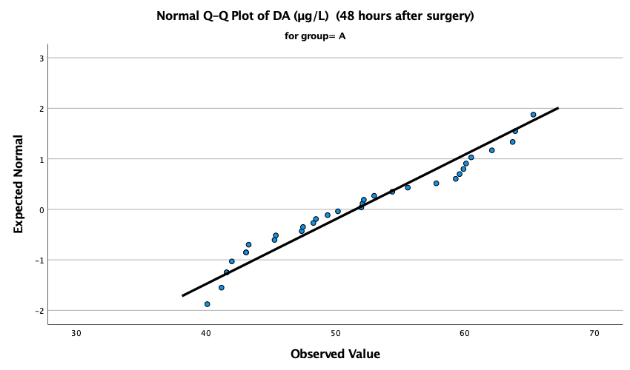
Supplementary Fig. 41 (Normal Q–Q plot of DA (µg/L) (48 hours after surgery) in group A.)
(Note: This figure shows the normal Q–Q plot for DA measured 48 hours after surgery in group A, comparing the observed values with the theoretical quantiles of a normal distribution. The data generally follow the reference line, suggesting an approximately normal distribution, although slight tail deviation may be present.)

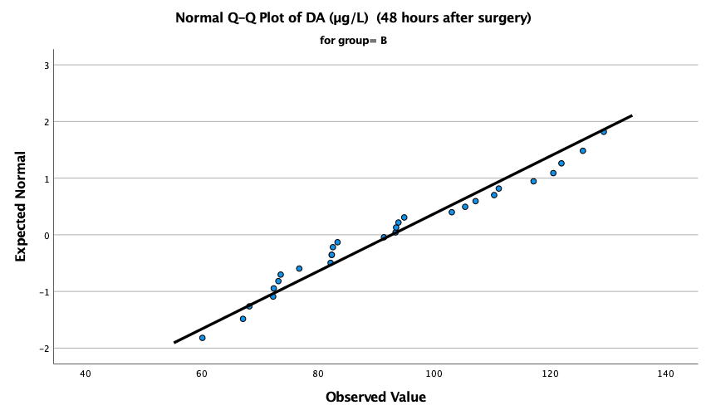
Supplementary Fig. 42 (Normal Q–Q plot of DA (µg/L) (48 hours after surgery) in group B.)
(Note: This figure shows the normal Q–Q plot for DA measured 48 hours after surgery in group B, comparing the observed values with the theoretical quantiles of a normal distribution. Most data points lie close to the reference line, suggesting an approximately normal distribution.)

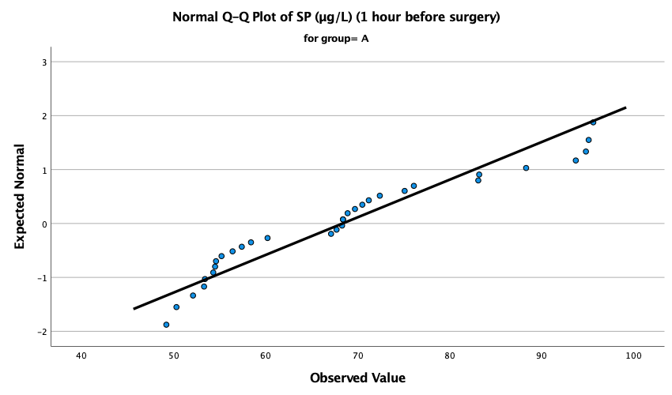
Supplementary Fig. 43 (Normal Q–Q plot of SP (µg/L) (1 hour before surgery) in group A.)
(Note: This figure shows the normal Q–Q plot for SP measured 1 hour before surgery in group A, comparing the observed values with the theoretical quantiles of a normal distribution. A visible deviation from the reference line is present, suggesting a departure from normality.)

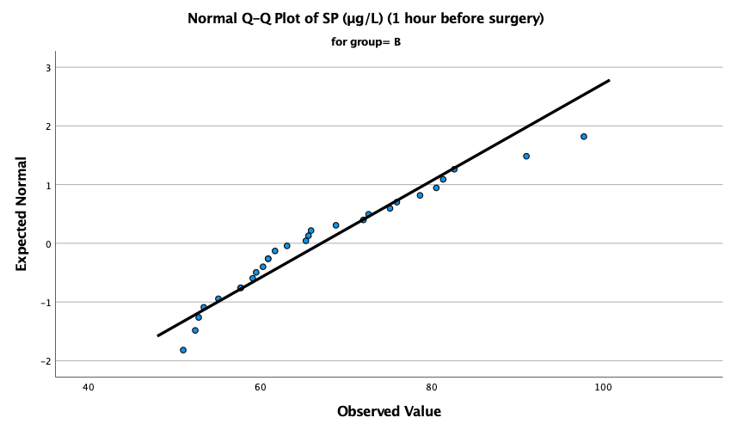
Supplementary Fig. 44 (Normal Q–Q plot of SP (µg/L) (1 hour before surgery) in group B.)
(Note: This figure shows the normal Q–Q plot for SP measured 1 hour before surgery in group B, comparing the observed values with the theoretical quantiles of a normal distribution. Most data points lie close to the reference line, suggesting an approximately normal distribution, although minor deviation may be present.)

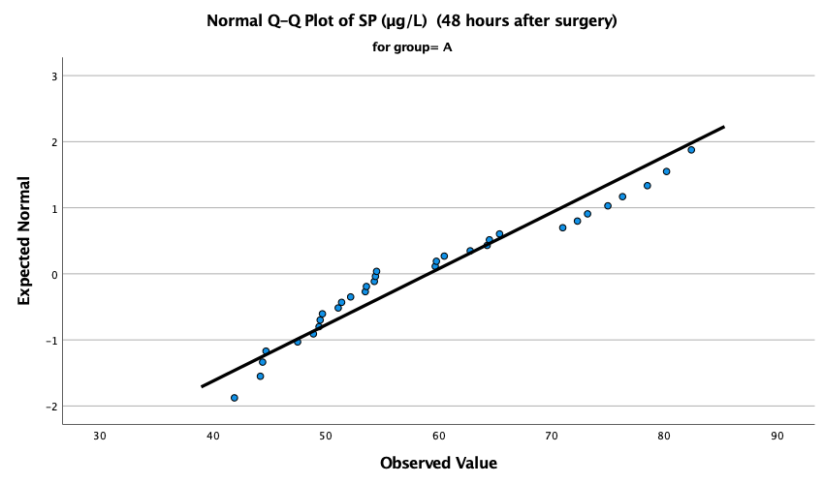
Supplementary Fig. 45 (Normal Q–Q plot of SP (µg/L) (48 hours after surgery) in group A.)
(Note: This figure shows the normal Q–Q plot for SP measured 48 hours after surgery in group A, comparing the observed values with the theoretical quantiles of a normal distribution. A slight deviation from the reference line is visible, suggesting a mild departure from normality.)

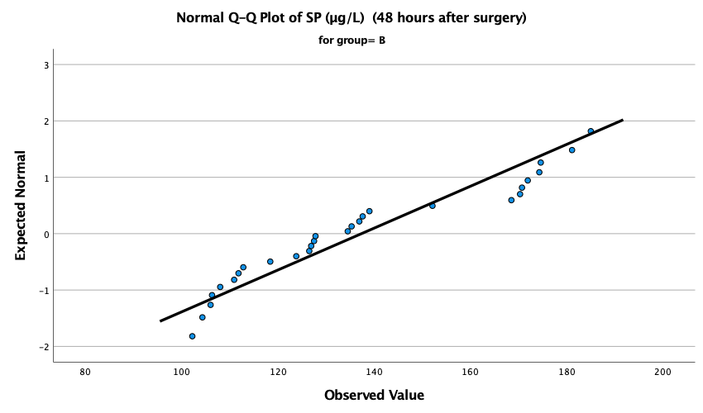
Supplementary Fig. 46 (Normal Q–Q plot of SP (µg/L) (48 hours after surgery) in group B.)
(Note: This figure shows the normal Q–Q plot for SP measured 48 hours after surgery in group B, comparing the observed values with the theoretical quantiles of a normal distribution. A visible deviation from the reference line is present, suggesting a departure from normality.)

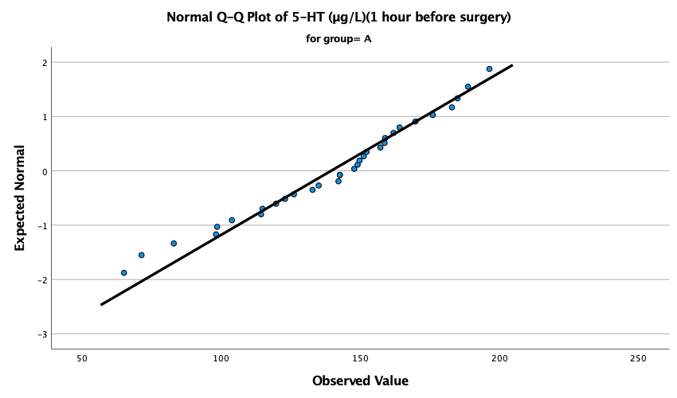
Supplementary Fig. 47 (Normal Q–Q plot of 5-HT (µg/L) (1 hour before surgery) in group A.)
(Note: This figure shows the normal Q–Q plot for 5-HT measured 1 hour before surgery in group A, comparing the observed values with the theoretical quantiles of a normal distribution. Most data points lie close to the reference line, suggesting an approximately normal distribution.)

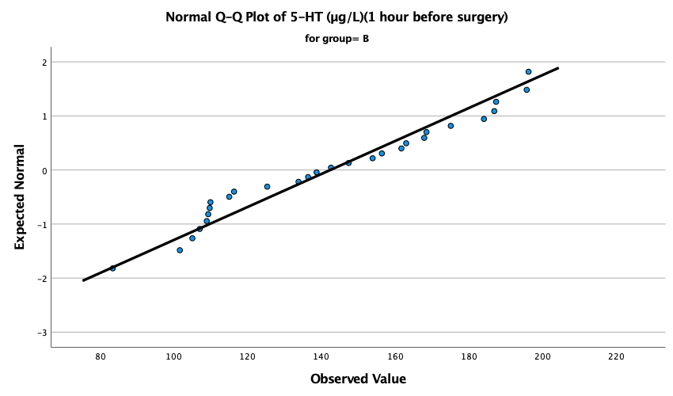
Supplementary Fig. 48 (Normal Q–Q plot of 5-HT (µg/L) (1 hour before surgery) in group B.)
(Note: This figure shows the normal Q–Q plot for 5-HT measured 1 hour before surgery in group B, comparing the observed values with the theoretical quantiles of a normal distribution. Most data points lie close to the reference line, suggesting an approximately normal distribution.)

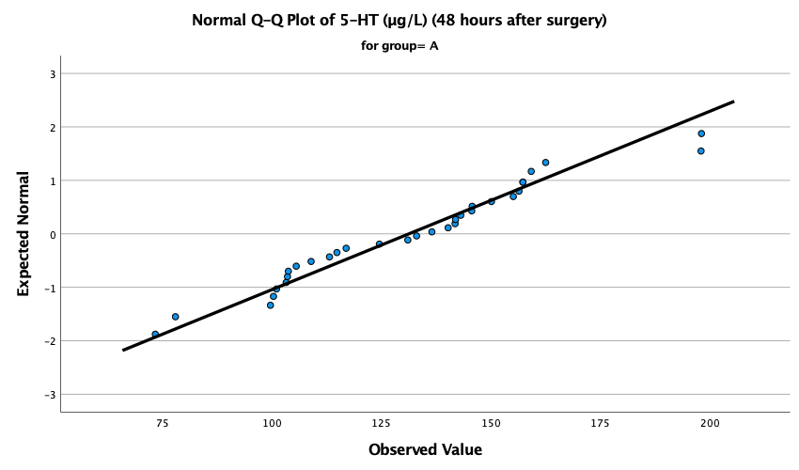
Supplementary Fig. 49 (Normal Q–Q plot of 5-HT (µg/L) (48 hours after surgery) in group A.)
(Note: This figure shows the normal Q–Q plot for 5-HT measured 48 hours after surgery in group A, comparing the observed values with the theoretical quantiles of a normal distribution. Most data points lie close to the reference line, suggesting an approximately normal distribution.)

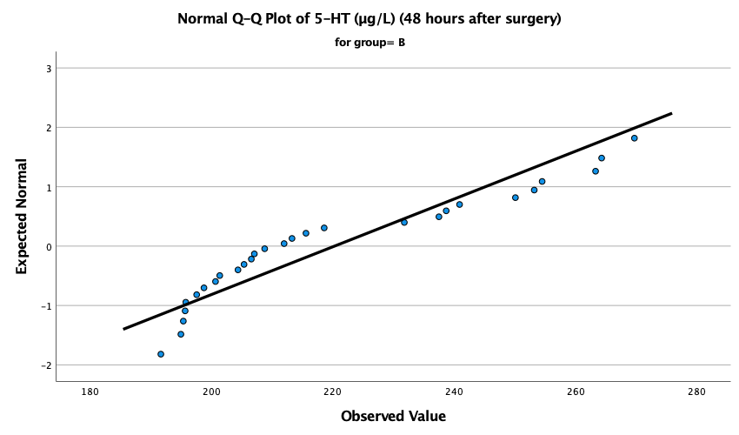
Supplementary Fig. 50 (Normal Q–Q plot of 5-HT (µg/L) (48 hours after surgery) in group B.)
(Note: This figure shows the normal Q–Q plot for 5-HT measured 48 hours after surgery in group B, comparing the observed values with the theoretical quantiles of a normal distribution. A clear deviation from the reference line is present, suggesting a departure from normality.)

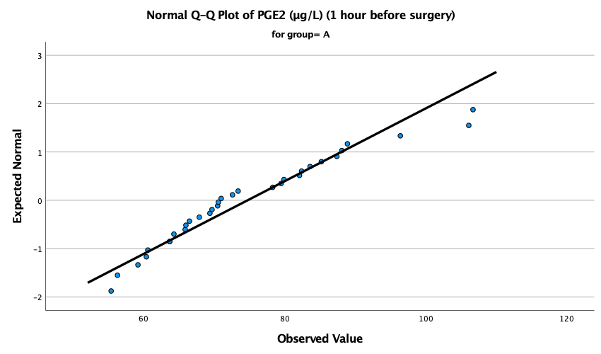
Supplementary Fig. 51 (Normal Q–Q plot of PGE2 (µg/L) (1 hour before surgery) in group A.)
(Note: This figure shows the normal Q–Q plot for PGE2 measured 1 hour before surgery in group A, comparing the observed values with the theoretical quantiles of a normal distribution. The data generally follow the reference line, suggesting an approximately normal distribution,
although slight deviation may be present.)

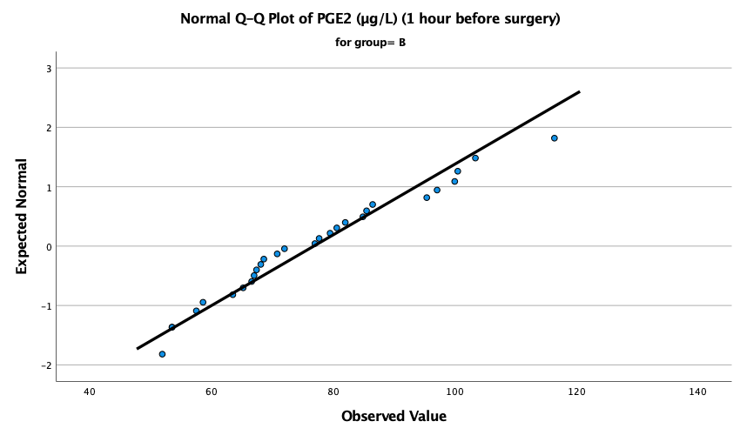
Supplementary Fig. 52 (Normal Q–Q plot of PGE2 (µg/L) (1 hour before surgery) in group B.)
(Note: This figure shows the normal Q–Q plot for PGE2 measured 1 hour before surgery in group B, comparing the observed values with the theoretical quantiles of a normal distribution. Most data points lie close to the reference line, suggesting an approximately normal distribution.)

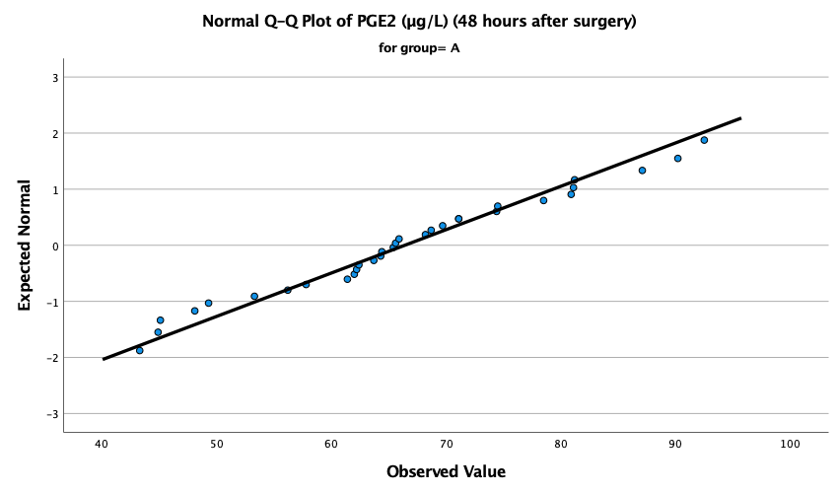
Supplementary Fig. 53 (Normal Q–Q plot of PGE2 (µg/L) (48 hours after surgery) in group A.)
(Note: This figure shows the normal Q–Q plot for PGE2 measured 48 hours after surgery in group A, comparing the observed values with the theoretical quantiles of a normal distribution. Most data points lie close to the reference line, suggesting an approximately normal distribution.)
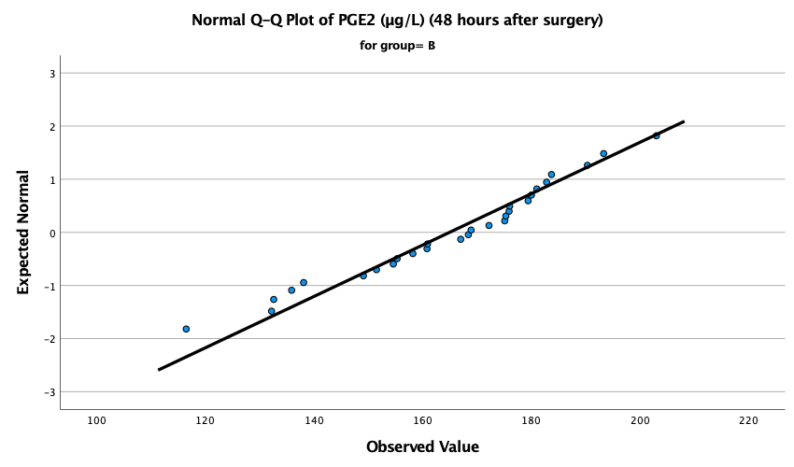
Supplementary Fig. 54 (Normal Q–Q plot of PGE2 (µg/L) (48 hours after surgery) in group B.)
(Note: This figure shows the normal Q–Q plot for PGE2 measured 48 hours after surgery in group B, comparing the observed values with the theoretical quantiles of a normal distribution. Most data points lie close to the reference line, suggesting an approximately normal distribution.)

